# 

# **Project Report: Online Loan and Verification System**

Submitted By

Rahul Kumar (1301043)



**DEPARTMENT OF COMPUTER SCIENCE AND ENGINEERING**

**INDIAN INSTITUTE OF INFORMATION TECHNOLOGY GUWAHATI**

Contents:

Abstract .……………………………………………………………………… 1

System Description …………………………………………………………….2

Features Admin Side …………………………………………………………...2

Admin Side Use Case Diagram ……………………………………………….. 2

Features Customer side …………………………………………………………3

Customer Side Use Case Diagram ……………………………………………...4

Activity Diagram Admin side …………………………………………………...5

Activity Diagram Customer side ………………………………………………..5

Class Diagram …………………………………………………………………...6

Sequence Diagram Admin side…………………………………………………. 7

Sequence Diagram Customer side……………………………………………….8

Software Requirements ………………………………………………………….8

Abstract:

|  |  |
| --- | --- |
| Project Title | Online loan and verification system |
| Objective | Main objective is to provide good interaction & communication facilities between customers & bank administrator and make the loan process easy and less time consumable.  Online Loan Management & Verification System make online the office activities for loan process of a bank.  Customer information, Database, Loan details and EMI details and payment maintain by administrators (bank employee). |
| Platform | Web-Base |
| Front End | Java/JDK1.6.0(JSP) |
| Back End | MySQL 5.1 |
| Project Duration | 90 Days |
| Submitted To | Department of Computer Science and Engineering, IIIT Guwahati |

System Description:

Features Admin Side:

1. Home Page
2. Login
3. Update Loan details

3.1 Loan type

3.2 Interest rate

3.3 EMI details

4. Manage EMI Payment

5. Manage Loan Application status

5.1 Pending or Rejected or Accepted

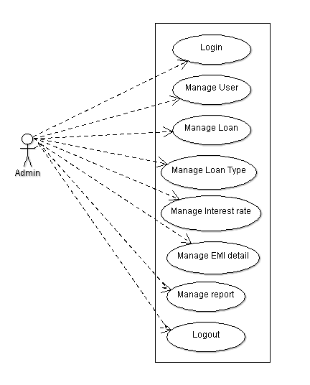

Figure 1: Admin side Use Case Diagram

1. Home Page:

Home page is the initial web page of our web-based application, from here admin can login their account and do their work.

1. Login:

It is the authentication step to authenticate where username and password are need to be given, if they are correct then authentication successful.

1. Update loan details:

Admin can update the loan details like loan type, interest rate, EMI details.

1. Manage EMI Payment:

Admin can manage the EMI payments, he/she can send the notice and notification to customer to fill their EMIs.

1. Manage Loan application status:

Admin can manage the loan application status that the application is pending or rejected or accepted.

Features Customer Side:

1. Home Page
2. Check Loan details

3.1 Loan type

3.2 Interest rate

3.3 EMI details

4. EMI Payment

5. Loan Application status

5.1 Pending or Rejected or Accepted

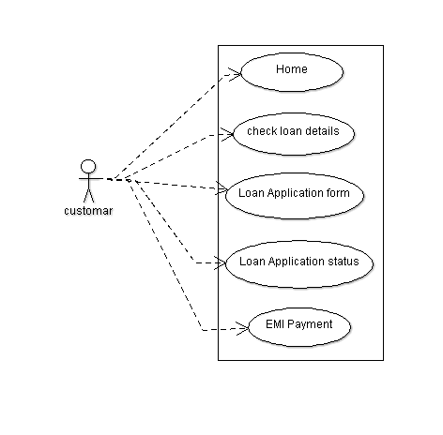

Figure 2: Customer side Use case diagram

1. Home Page:

Home page is the initial web page of our web-based application.

1. Check Loan details:

A customer can search a best suited loan by searching the loan details.

1. Loan Application Form:

For applying a loan customer need to fill the loan application form , where he or she provide the details.

1. Loan Application Status:

After applying for the loan customer can check his or her application status whether his or her application is pending or accepted or rejected.

1. EMI Payment:

Customer can pay the loan on EMI basis , he or she can make online EMI payment.

Activity Diagram Admin side:

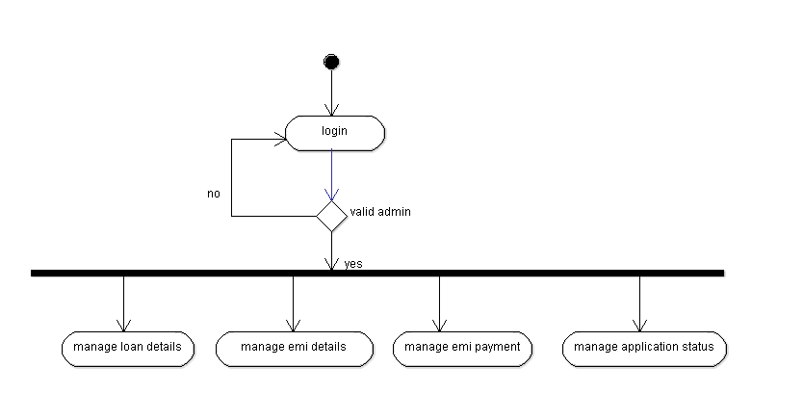

Figure 3: Activity diagram admin side

Activity diagram Customer side:

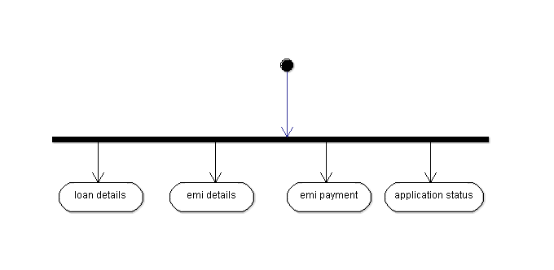

Figure 4: Activity diagram Customer side

Class Diagram:

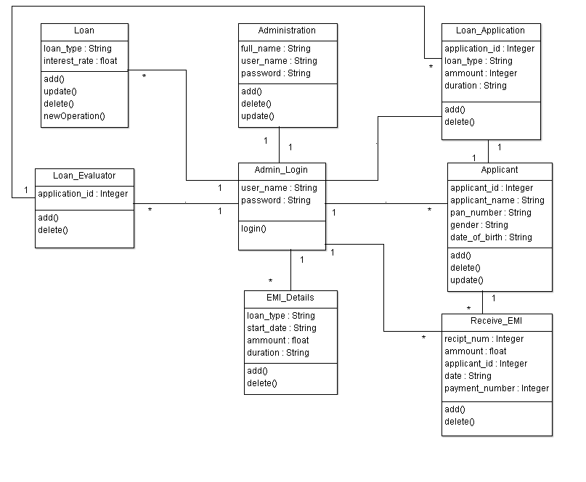

Figure 5: Class Diagram

Sequence Diagram Admin Side:

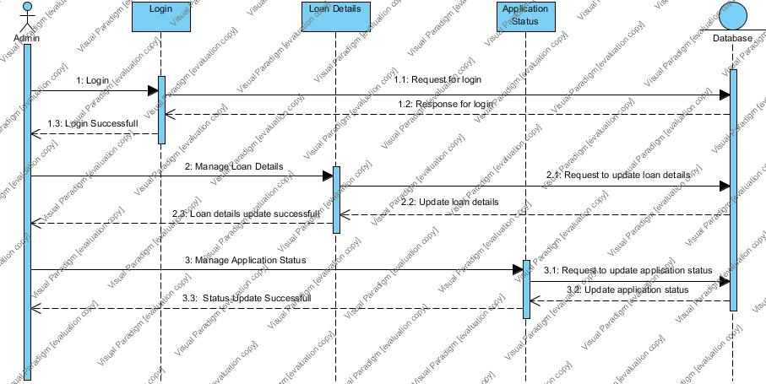

Figure 6: Sequence diagram admin side

Sequence Diagram Customer Side:

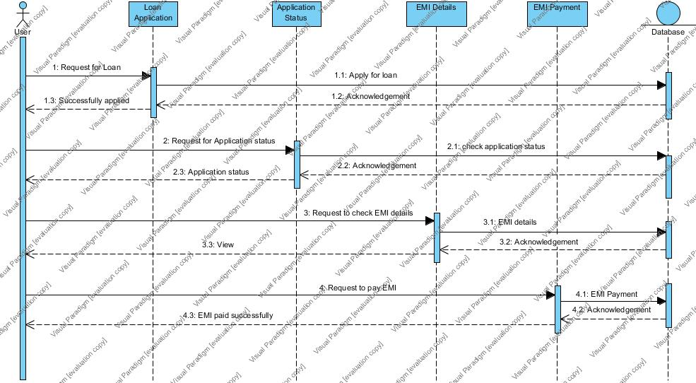

Figure 7: Sequence diagram customer side

Software Requirement:

Server side:

|  |  |
| --- | --- |
| Operating System | Microsoft Windows 7 or later |
| Web Server | Apache Tomcat 7.0 or later |
| Front End Tools | Java/jdk 1.6.0(JSP) |
| Back End Tools | MYSQL Server 5.1 |

Client side:

|  |  |
| --- | --- |
| Operating System | Microsoft windows 7 or later or any compatible OS |
| Web Browser | Google Chrome or any compatible web browser |